# Business Analyst

**What’s the need for Business Analyst?**

Business analysts are needed to help businesses improve their performance by analysing data and identifying areas for improvement. They help businesses make data-driven decisions that can increase efficiency and reduce costs.

**What is Business Analyst?**

A business analyst (BA) is a professional who analyzes business data to identify problems and recommend solutions. They work to improve business efficiency by ensuring that business goals align with technical capabilities.

**Business Analyst Responsibilities**

* **Analyze business problems**: Identify problems, opportunities, and risks
* **Research and analyze**: Understand how a business works, including its processes, data, and technology
* **Identify areas for improvement**: Find ways to increase efficiency and strengthen business processes
* **Develop plans**: Create strategies to address problems and implement changes
* **Communicate findings**: Share findings with stakeholders and help implement changes
* **Support change management**: Help employees adapt to new systems and processes
* **Monitor and evaluate**: Track the impact of changes and ensure they achieve desired outcomes

**Business Analyst Skills**

* **Communication**: Clearly communicate findings to stakeholders through presentations, meetings, and written reports
* **Critical thinking**: Understand and analyze problems and find solutions
* **Problem solving**: Think creatively and work collaboratively to solve business challenges
* **Technical proficiency**: Be competent with data analysis and presentation software
* **Project management**: Be able to plan, monitor, and manage projects

**Agile Methodology**

Agile methodology is a project management process that emphasizes flexibility, collaboration, and continuous improvement. It's used in business analysis to help teams deliver value to customers quickly and efficiently.

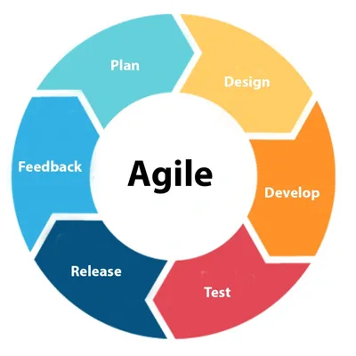

**What does an Agile Business Analyst do?**

* **Facilitates communication**

An Agile Business Analyst (BA) acts as a mediator between stakeholders and the development team. They ensure that the team understands the client's needs and requirements.

* **Prioritizes value**

An Agile BA helps the team identify and prioritize business value. They also help the team make decisions that are driven by value.

* **Ensures alignment**

An Agile BA helps ensure that the project is aligned with stakeholder expectations. They do this by making real-time adjustments to the project scope and direction.

* **Incorporates technology**

An Agile BA can introduce a systems perspective to the project. They can help the team turn business needs into technology workflow management.

**What are some characteristics of Agile methodology?**

* **Iterative development**

Agile methodology breaks projects into phases called "sprints". Teams work through these sprints repeatedly, inspecting and improving the software at the end of each iteration.

* **Continuous feedback**

Agile methodology encourages frequent communication and feedback between the team and stakeholders.

* **Self-organization**

Agile methodology encourages teams to be self-organizing and cross-functional.

**Software Development Life Cycle (SDLC)**

Software Development Life Cycle (SDLC) typically involves participating in all phases, from initial planning and requirement analysis to design, development, testing, implementation, and maintenance, ensuring the project aligns with business needs throughout the process by clearly defining and communicating requirements to the development team.

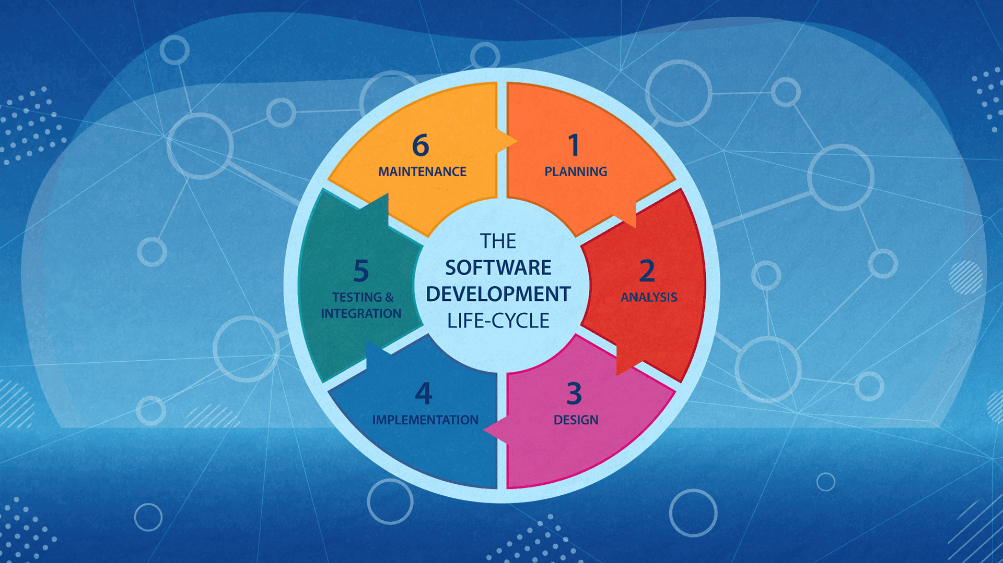

**Role of Business Analyst in the Software Development Life Cycle:**

* Software has become an integral part of almost every type of work. For most businesses out there, software is the main component for speeding up processes and elevating the overall quality of production and customer service to the next level.
* The progress that we as people have made in the realm of software development during these last 5-10 years has significantly changed the global market. The business world is now moving faster than ever and companies are turning to software to help them expedite their business operations.
* Building or adopting the best type of software that has the ability to serve the company with proper insights and enable it to work smarter and faster is now a top item on almost every major company’s priority list.
* However, even though the desire is there, most companies still struggle to build/adopt/adapt solutions that will actually help them successfully optimize their work, reduce cost, fully automate mundane tasks, and claim better positions to attract customers.
* The main reason why this is still so hard for many enterprises out there has a lot to do with how they think about these technological solutions and how they start building them. Speaking from experience working with various enterprise-level clients, most of them don’t have a business analyst that’s involved in the software development process right from the start.

**Kanban Methods**

Kanban is a project management methodology that helps visualize work in progress (WIP) and optimize flow in Agile software development. It's a "pull" system that uses a Kanban board to signal when to move work to the next step.

**How it works**

* Visualize workflow: Use a Kanban board to represent the workflow as steps.
* Limit WIP: Set a limit on how much work can be in progress at once.
* Focus on flow: Encourage teams to finish work before taking on new work.
* Continuous improvement: Pursue incremental change and optimize cycle time.

**Benefits:**

Increases transparency

* Visualizing the project on a board increases collaboration and transparency between team members.

Communicates capacity

* WIP limits communicate to stakeholders that there is limited capacity to do work.

Helps manage projects

* Kanban is a simple framework that helps project managers keep track of their projects.

**When to use Kanban**

* Kanban is well suited for continuous flow work, such as support and services.

**Product backlog**

In business analysis, a "product backlog" refers to a continuously updated, prioritized list of all the features, functionalities, and requirements that a development team intends to build for a product, essentially acting as a comprehensive roadmap of what needs to be developed, with the most important items listed at the top for focused delivery.

**Key points about a product backlog:**

* **Dynamic and evolving:**

The product backlog is not static and should be regularly refined based on new feedback, changing market conditions, and business priorities.

* **Prioritization:**

Each item in the backlog is assigned a priority level, allowing the team to focus on the most valuable features first.

* **Role of the business analyst:**

Business analysts play a crucial role in gathering requirements, defining user stories, and ensuring the product backlog accurately reflects the business needs and priorities.

**How to manage a product backlog:**

* **Gather requirements:**

Conduct user research, stakeholder interviews, and analysis to identify necessary features and functionalities.

* **Create backlog items:**

Write detailed descriptions for each feature, including user stories and acceptance criteria.

* **Prioritize backlog items:**

Use prioritization techniques like MoSCoW, RICE, or Kano model to rank items based on business value and urgency.

* **Regular refinement:**

Continuously update the backlog by adding new items, removing completed items, and re-prioritizing as needed.

**Sprint planning**

In business analysis, "sprint planning" refers to a collaborative meeting at the beginning of each agile development "sprint" where the team, including the business analyst, decides which user stories from the product backlog they will focus on completing during that specific sprint, essentially defining the work scope and goals for the upcoming iteration, ensuring everyone is aligned on the priorities and deliverables for the next development cycle.

**Key points about sprint planning for business analysts:**

* **Role in the process:**

Business analysts play a crucial role in sprint planning by providing detailed information about user stories, acceptance criteria, and business requirements, helping the team understand the context and value of each work item.

* **Collaboration with the team:**

They actively participate in discussions with the product owner, developers, and scrum master to choose the most valuable user stories to include in the sprint backlog.

* **Prioritization and refinement:**

Business analysts may help prioritize user stories based on business impact and complexity, ensuring the team focuses on the most critical features for each sprint.

* **Clarifying requirements:**

During sprint planning, the business analyst is responsible for clarifying any ambiguities or questions related to user stories to ensure the development team has a clear understanding of what needs to be delivered.

**Benefits of sprint planning for business analysts:**

* **Improved communication:**

It facilitates open communication between the business and development teams, ensuring everyone is on the same page about project priorities and deliverables.

* **Early feedback:**

Business analysts can get early feedback on requirements and user stories from the development team during sprint planning.

* **Focus on value:**

By actively participating in sprint planning, business analysts can help ensure that the team is focused on delivering the most valuable features for the business.

**User Stories**

User stories in business analysis are short statements that describe a user's need for a product or service. They are written from the user's perspective and help business analysts understand the user's needs.

**What are user stories used for?**

* **Communicate user needs**

User stories help business analysts understand what users want and how a product or service can help them.

* **Guide development**

User stories help developers and testers understand how to implement features that meet the user's needs.

**How are user stories written?**

* **Use the 5 W's**: Consider who the user is, what they want, when they want it, where they want it, and why they want it.
* **Use the 3 C's**: Consider the card, conversation, and confirmation of the user story.
* **Include acceptance criteria**: Define the conditions that must be met for the user story to be considered complete.

**When are user stories used?**

* User stories are often created from discussions, observation sessions, and brainstorming.
* They can be used to address issues or defects in software, also known as bug user stories.

**Scrum**

Scrum is a framework that helps teams work together to achieve a common goal in business analysis. It's an Agile framework that's popular for managing complex projects.

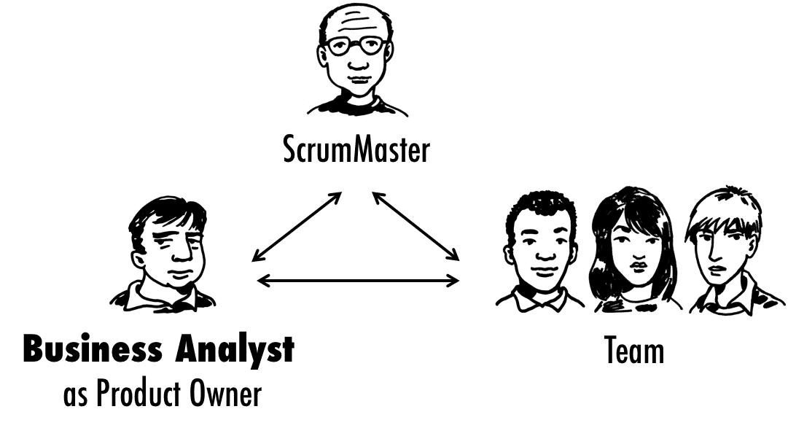

How Scrum works

* **Sprints**

Scrum breaks down complex tasks into smaller, more manageable units called sprints. Sprints usually last 2–4 weeks.

* **Goals**

Each sprint has specific goals that the team plans, executes, reviews, and assesses.

* **Collaboration**

Scrum encourages collaboration and self-management, similar to how a sports team practices for a big game.

**The role of a business analyst in Scrum**

* **Translate business needs**

Business analysts translate complex business needs into user stories and acceptance criteria.

* **Work with the development team**

Business analysts work with the development team to ensure that solutions are technically sound and meet business objectives.

* **Review test cases**

Business analysts work with quality assurance (QA) to review test case coverage. This helps them understand the product's functionality, business rules, and customer expectations.

* **Act as a product owner**

Depending on the project, a business analyst can act as a product owner.

**Jira Board**

A "Jira board" in business analysis refers to a visual tool within the Jira project management software that allows business analysts to effectively track the progress of requirements, issues, and tasks throughout a project lifecycle, providing a clear overview of the work in different stages (like "To Do," "In Progress," and "Done") through a user-friendly, column-based interface, which is particularly valuable for Agile methodologies where continuous updates and collaboration are crucial; essentially acting as a central hub for managing project details and facilitating communication between stakeholders.

**Key points about using a Jira board in business analysis:**

* **Visual representation:**

The board displays tasks as cards that can be moved across columns representing different workflow stages, offering a visual representation of project progress at a glance.

* **Requirement management:**

Business analysts can create user stories and detailed requirements as "issues" on the Jira board, enabling effective tracking and prioritization.

* **Agile alignment:**

Jira boards are well-suited for Agile methodologies like Scrum and Kanban, allowing for sprint planning, backlog management, and iterative development.

* **Collaboration tool:**

The shared nature of the board encourages team collaboration, as everyone can see the current status of work and contribute updates.

* **Customizable workflows:**

Jira boards can be customized with columns and statuses that align with specific project needs and business analysis processes.

**How business analysts utilize a Jira board:**

* **Create user stories:**

Break down complex requirements into manageable user stories and add them as issues on the board.

* **Prioritization:**

Assign priority levels to issues to focus on the most critical tasks first.

* **Sprint planning:**

Use the board to plan upcoming sprints by assigning user stories to specific team members and timeframes.

* **Status updates:**

Regularly update the status of issues by moving cards between columns to reflect progress.

* **Issue tracking:**

Monitor and resolve any roadblocks or issues that arise during the project by utilizing the issue tracking features.